

Semester Two Examination, 2016

Question/Answer Booklet

MATHEMATICS

If required by your examination administrator, please place your student identification label in this box
APPLICATIONS
UNITS 1 AND 2

Section One:

Calculator-free

Student Number: In figures

In words

Your name

Time allowed for this section
Reading time before commencing work: five minutes
Working time for section: fifty minutes

Materials required/recommended for this section
To be provided by the supervisor
This Question/Answer Booklet
Formula Sheet

To be provided by the candidate
Standard items: pens (blue/black preferred), pencils (including coloured), sharpener, correction fluid/tape, eraser, ruler, highlighters

Special items: nil

Important note to candidates
No other items may be taken into the examination room. It is your responsibility to ensure that you do not have any unauthorised notes or other items of a non-personal nature in the examination room. If you have any unauthorised material with you, hand it to the supervisor before reading any further.

Structure of this paper

Section | Number of questions available | Number of questions to be answered | Working  time (minutes) | Marks available | Percentage of exam
Section One:  Calculator-free | 7 | 7 | 50 | 51 | 35
Section Two:  Calculator-assumed | 13 | 13 | 100 | 99 | 65
 |  |  | Total | 150 | 100

Instructions to candidates

1. The rules for the conduct of examinations are detailed in the school handbook. Sitting this examination implies that you agree to abide by these rules.

2. Write your answers in this Question/Answer Booklet.

3. You must be careful to confine your response to the specific question asked and to follow any instructions that are specified to a particular question.

4. Spare pages are included at the end of this booklet. They can be used for planning your responses and/or as additional space if required to continue an answer.
- Planning: If you use the spare pages for planning, indicate this clearly at the top of the page.
- Continuing an answer: If you need to use the space to continue an answer, indicate in the original answer space where the answer is continued, i.e. give the page number. Fill in the number of the question that you are continuing to answer at the top of the page.

5. Show all your working clearly. Your working should be in sufficient detail to allow your answers to be checked readily and for marks to be awarded for reasoning. Incorrect answers given without supporting reasoning cannot be allocated any marks. For any question or part question worth more than two marks, valid working or justification is required to receive full marks. If you repeat any question, ensure that you cancel the answer you do not wish to have marked.

6. It is recommended that you do not use pencil, except in diagrams.

7. The Formula Sheet is not to be handed in with your Question/Booklet.

Section One: Calculator-free 35% (51 Marks)
This section has seven (7) questions. Answer all questions. Write your answers in the spaces provided.

Working time for this section is 50 minutes.

Question 1 (6 marks)
(a) If $a=10$, $t=2$ and $u=5.5$, determine the value of $s$, where $s=ut+\frac{1}{2}at^{2}$. (2 marks)

(b) If $m=\frac{a+b+c}{3}$, determine the value of $a$ when $b=10$, $c=13$ and $m=9$. (2 marks)

(c) If $d=\sqrt{b^{2}-4ac}$, determine the value of $a$ when $b=3$, $c=-1$ and $d=5$. (2 marks)

Question 2 (7 marks)
A group of 28 people gave a movie they had just watched together a rating of between one and five stars. Their star ratings are listed below:
2 | 4 | 4 | 2 | 2 | 1 | 4 | 4 | 4 | 2 | 4 | 3 | 3 | 1
5 | 2 | 4 | 5 | 2 | 4 | 4 | 2 | 2 | 3 | 2 | 5 | 4 | 3

(a) Explain why this type of data is considered categorical and choose one more word to further describe the data from the following list: nominal, ordinal, discrete, continuous.
(2 marks)

(b) Complete the frequency table below for the ratings. (2 marks)

Rating | Tally | Frequency
1
2
3
4
5

(c) Display the ratings as bar graph using the grid below. (3 marks)

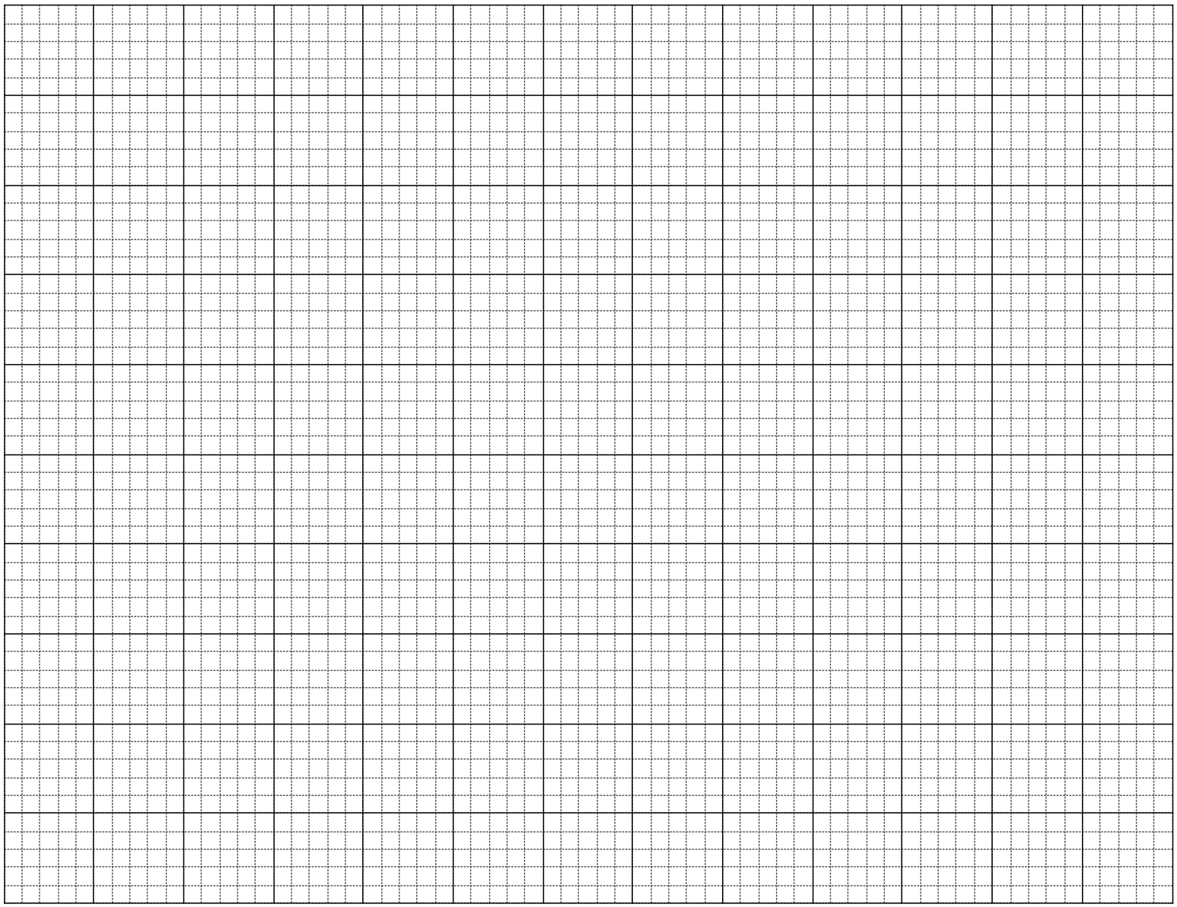

Question 3 (7 marks)
Consider the matrices $A=\left[\begin{matrix}2 & 1 \\ -1 & 3\end{matrix}\right]$, $B=\left[\begin{matrix}5 \\ -3\end{matrix}\right]$, $C=\left[\begin{matrix}3 & -2 \\ 1 & 0\end{matrix}\right]$ and $D=[\begin{matrix}6 & 2\end{matrix}]$.

(a) Calculate, where possible, the following. If not possible, explain why.

(i) $5C$. (1 mark)

(ii) $2D+3B$. (1 mark)

(iii) $A-C$. (1 mark)

(iv) $AC$. (2 marks)

(b) Determine the value of $x$ if $\left[\begin{matrix}2 & -2 & x\end{matrix}\right]×\left[\begin{matrix}x \\ 4 \\ 3\end{matrix}\right]=[4x]$. (2 marks)

Question 4 (9 marks)
The graph below, developed by Monsieur Le Beau, can be used to determine if a cat is old or young in relation to human age. For example, a one-year-old cat ($c=1$) will have the equivalent age of a fifteen-year-old human ($h=15$).

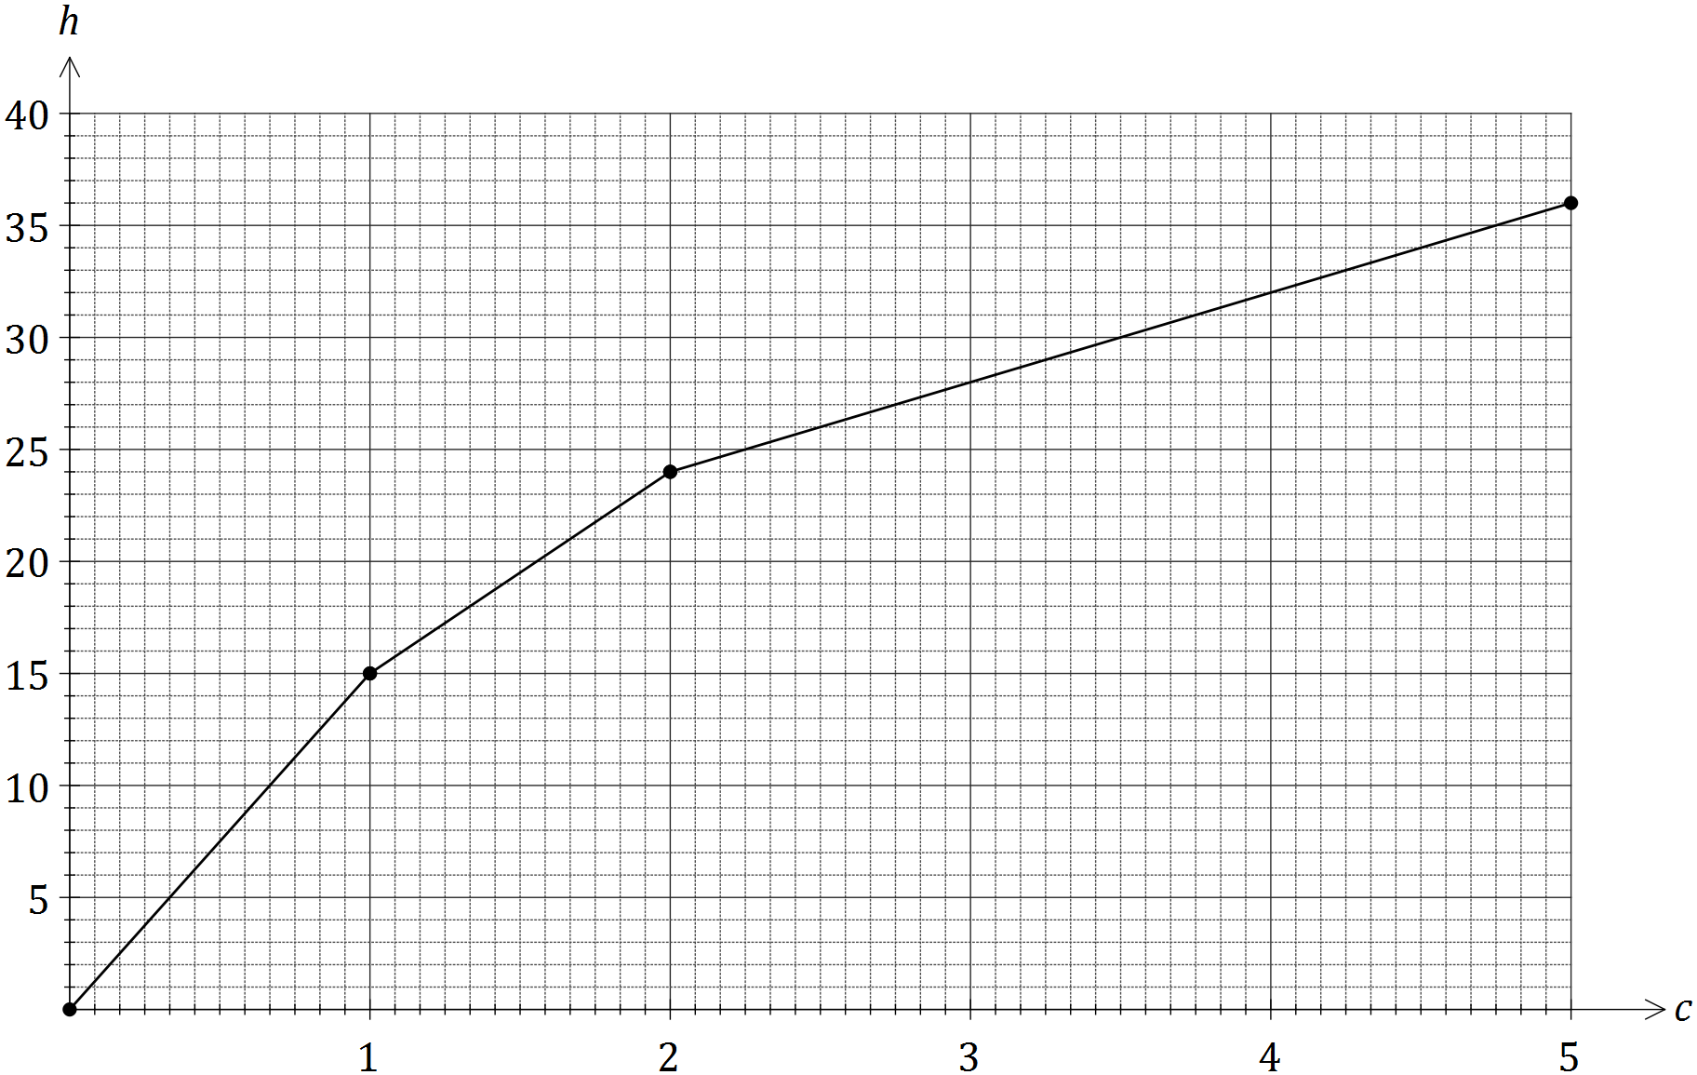

(a) Use the graph to determine

(i) the equivalent human age of a cat that is four and a half years old. (1 mark)

(ii) the age of a cat with an equivalent human age of 18 years. (1 mark)

(b) Calculate the gradient of the line for cats that are between one and two years old, and interpret what its value means in this context. (2 marks)

(c) Determine the equation of the line for cats that are two years or older. (3 marks)

(d) Use your equation from (c) to determine the age of a cat with an equivalent human age of 60 years. (2 marks)

Question 5 (9 marks)
The distributions of the percentage exam scores of a group of 39 students in Section One and Section Two of their Mathematics exam are shown below.

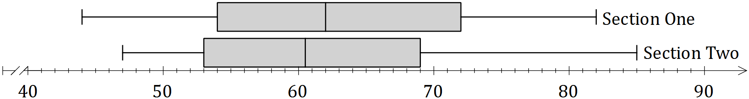

(a) Discuss, with reasoning based on statistics from the above distributions, in which section the students achieved better marks. (3 marks)

(b) Discuss, with reasoning based on statistics from the above distributions, in which section the students' performance was more consistent. (3 marks)

(c) A teacher suspected that the data set for one section may contain an outlier.

(i) State which data set and a brief reason for their suspicion. (1 mark)

(ii) Use a calculation to determine whether the data set identified above contains an outlier. (2 marks)

Question 6 (6 marks)
The table below shows the number of overseas (O) and local (L) letters sent by a company over a period of five consecutive days.

Mon |  | Tue |  | Wed |  | Thu |  | Fri
O | L | O | L | O | L | O | L | O | L
0 | 8 | 2 | 5 | 1 | 10 | 5 | 15 | 3 | 6

(a) Represent this information in a $2×5$ matrix $M$. (2 marks)

(b) The cost of sending a local letter is $1 and an overseas letter is $3. Show this information in matrix $C$ that can be multiplied by matrix $M$ to create a meaningful result. (1 mark)

(c) Calculate the product of the two matrices from (a) and (b) and explain what information this matrix shows. (2 marks)

(d) Multiplying your answer to (c) by another matrix $T$ will result in a $1×1$ matrix that represents the total cost of sending the letters over the five-day period. Determine a suitable matrix $T$. (1 mark)

Question 7 (7 marks)
A prism, with a right-triangular cross-section and square base, has dimensions as shown in the diagram below.
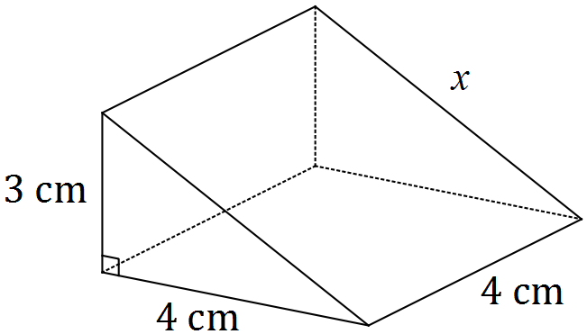

(a) Use Pythagoras' Theorem to show that the sloping edge marked $x$ is 5 cm long. (1 mark)

(b) Calculate the total surface area of the prism. (2 marks)

(c) Calculate the volume of the prism. (1 mark)

(d) The prism is a $1:n$ scale model of a larger solid that has a square base measuring 28 cm by 28 cm.

(i) State the value of the scale factor $n$. (1 mark)

(ii) The total surface area of the larger solid can be determined by multiplying your answer to (b) by $k$. State the value of $k$. (1 mark)

(ii) Write down a calculation that would give the volume of the larger solid, but do not evaluate it. (1 mark)

Additional working space

Question number: _________

© 2016 WA Exam Papers. Narrogin Senior High School has a non-exclusive licence to copy and communicate this paper for non-commercial, educational use within the school. No other copying, communication or use is permitted without the express written permission of WA Exam Papers. SN131-83-0-0-1.

